Hi Jason
Apologies on the delay providing this list of concerns/grievances pulled together by our group of EVA owners. Please see the info below.
Many our concerns (grievances is perhaps a better term) stem from ECI failing to deliver on promises/contractual elements. The recent addition of a 15% IVA to the $148/month ($1776/year) HOA came as a surprise to all owners as there was no mention of an IVA in our contract.
We appreciate your willingness to discuss this issue with us, and we feel it is important to demonstrate why we are concerned by this most recent change to our contract, as in all instances, it is we the owners who have been had to forgo what was promised rather than ECI/GP stepping up to the plate to honour what they presented to owners who agreed to purchase.
There are some fairly significant items that ECI did not deliver, nor did they consult or advise any owner of their decision to change them, that were key reasons why many of us bought in the EVA development. The most notable of these were (see screen shots included):
- grey water system (to water plants/gardens),
- rain water harvesting (to water plants/gardens),
- green roof (to help insulate homes),
- an unobstructed beach front access as demonstrated by the brochure presented to potential buyers in 2021 prior to purchase (and just before the announcement of the BELA community).
These promises were and many still are promoted the ECI EVA promotional webpage and were part of the promotional webinars attended by potential owners.
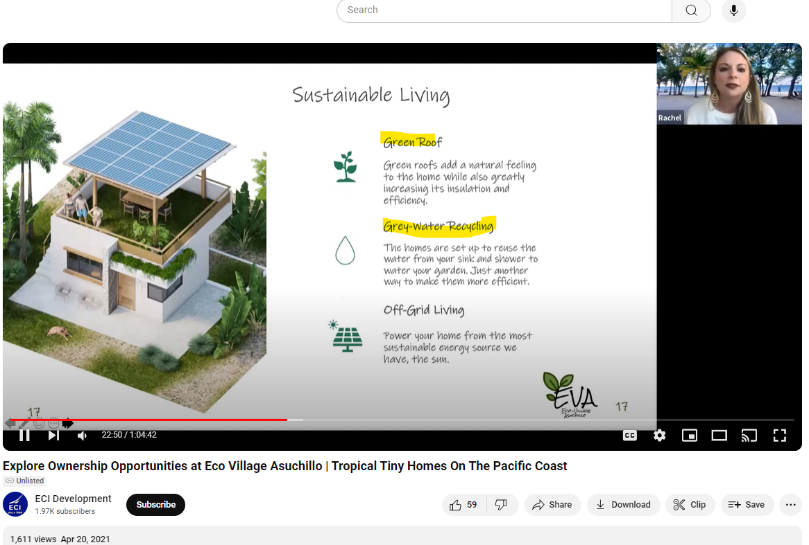
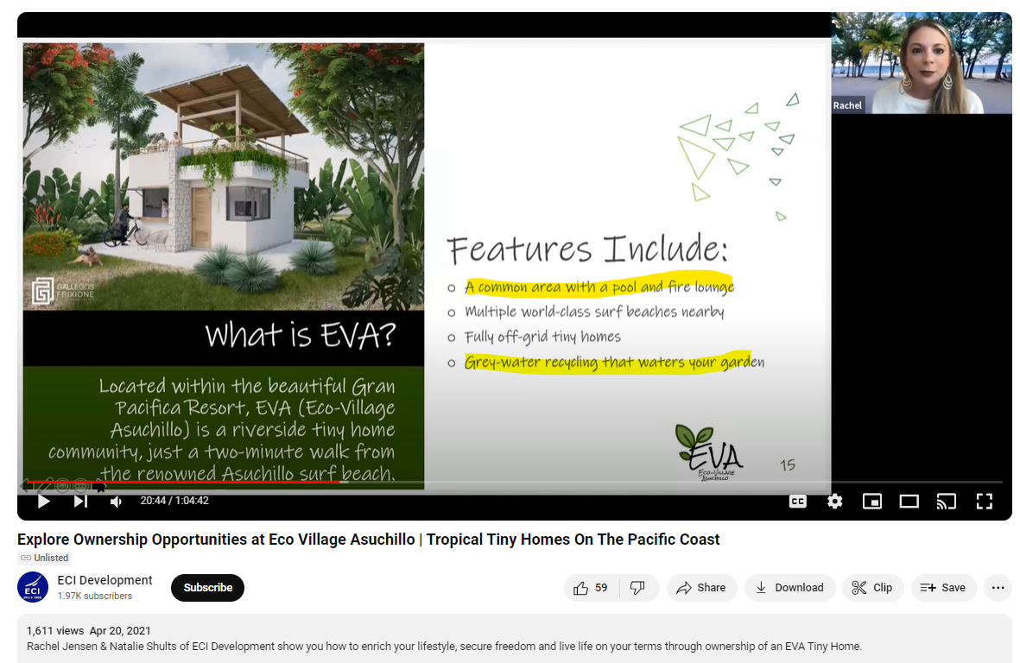
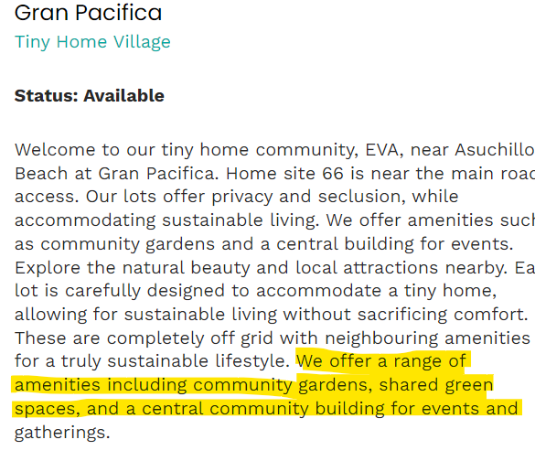
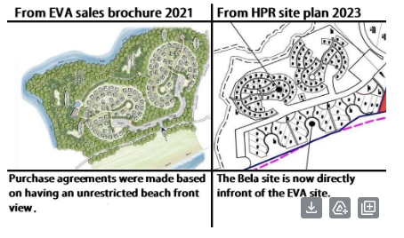

Other perhaps less significant but equally important elements promised also remain outstanding which include as a minimum; bike racks, street lighting, house numbering.
Additionally, numerous promises were advertised in online brochures and/or were discussed on webinars as far back at 2021 (e.g. wifi and work area at pool, fire pit, orchards, yoga palapa, butterfly gardens, bird watching/feeding centre etc.). See the below screenshot with latest image available on the ECI website which still lists these amenities that have not been provided but BELA has been added.
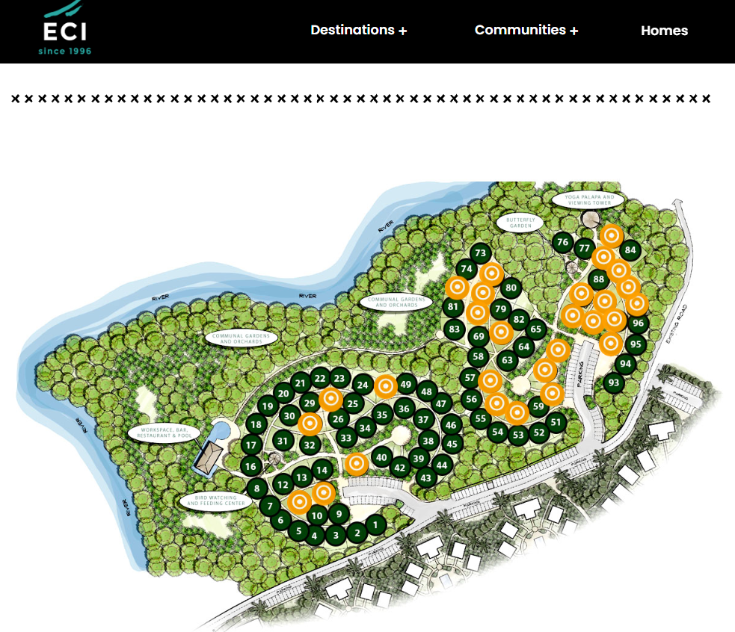
Additional items noted by owners:
- The quality of work completed in the EVA community has been poor in several respects. The most notable of these are the sidewalks. EVA sidewalks, appear to have been haphazardly completed and are very unattractive when compared to what has been installed in the BELA community (see photos below for comparison). A silica / sand mixed with a small amount of lime between the stone and swept it in. It hardens like concrete over time, but looks like sand.. 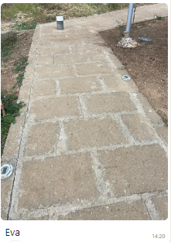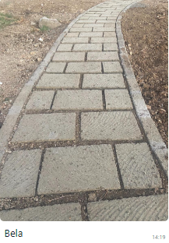

- There wasn't any wall art included in the bathroom for the furniture packages and the smart tech packages were substandard amazon resell/repurpose products. The wifi cameras need to have a subscription to be used which was never disclosed to us and is at an extra cost.

- Non-slip tiles needed to be used on the upper floor that is exposed to the elements. The tiles used on this upper level match the interior tiles and not the exterior, non-slip tiles used on the base level of each unit. The builder selected and installed glossy indoor tiles that were purchased in bulk to keep costs without consulting owners leading to a safety issue. This is a major slip hazard (one owner has already hurt themselves slipping on the floor) and when the builder was asked to coat the tiles with a non-slip spray, the product used to create a safer environment and fix this, quickly rubbed off and made a mess of the tiling on the exterior floors, which now requires owner clean up. These dangerous tiles need to be removed and owners should have new, non-slip tiles to remove this dangerous hazard.

- No English operation manuals were provided for the solar system leading to maintenance issues because there was/is no product awareness. These new solar systems have already proven themselves to fail, even on days with full sun. Random systems were selected so there is often a different issue that is inconsistent with other owner units.

- The band new EVA pool liner is already peeling and needs to be addressed. This pool was installed and officially opened in February 2024, so just over 5 months ago.

- There needs to be a clean and paved path to the EVA pool from all homes.

- The gym being marketed within Gran Pacifica is substandard. Treadmill doesn't work, the weight bench bar is the wrong one for the type of weights they have which makes it unusable. The gym is a storage room for bikes and surfboards. There needs to be HOA money that goes into the gym before they should be marketing it out.

For transparency purposes, it is worth noting that the EVA pool and associated palapa were recently delivered though some elements are not yet complete and degradation of the pool liner is already apparent. A community garden area is available (since fall 2022), but no action by ECI or GP was initiated until after a homeowner invested his own money to get a water line installed and a group of owners met with Mike Cobb to demand action. A yoga palapa is being build in GP, but not on the EVA site – which isn’t in line with the advertising.
The greater amenities within Gran Pacifica for property owners need to be improved upon and need to be free of charge to owners to make this place more attractive for future owners.
For example, if our HOA money is going into the golf course, we as owners should have free memberships and the general public should pay.

As owners, we are now being asked to pay additional funds on top of an HOA when many amenities have been left undelivered or fail to meet what was promoted. Unmet promises are being overlooked and we are being told to accept the current situation without the original contract terms being met. In essence, ECI, GP and now the GPMA is telling us that the contract we signed wasn’t worth the paper it was printed on and we should have to continue to absorb the costs and lack of accountability, instead of the organization we contracted with on an honourable basis.

Discussion Questions:
- How is the HOA/POA amount determined for each neighbourhood?
- How much of the EVA HOA payments will stay in the EVA community?
- How/where are community HOA funds held – is each community a separate account?
- How is the GPMA ensuring the use of HOA funds are appropriate and not excessive?
- How do community HOAs factor into the GPMA?

